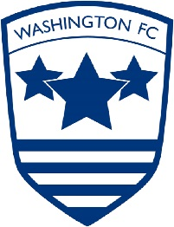
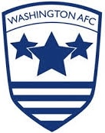
WASHINGTON AFC & FC LOTTERY BINGO

Pick 6 numbers. 1 – 59. Costs £5 a line per game
Choose how many lines of numbers you would like.
Each Wednesday and Saturday on the main national lottery draw, any numbers you have that are also in the main draw (not including bonus ball) are ticked off.
The numbers in each draw will be deemed to be simultaneous, so no number will have preference.
The winner(s) shall be the first member(s) to mark off all six numbers.
In the event of more than one member completing their line during the same draw, the prize money will be shared.
Any winning person in arrears will not be paid out, and the fund will roll over to the next pot. Where there are joint winners in this situation, the prize fund will be split between those winners who are not in arrears.
Please contact Lee Holmes with your numbers and he will collate all of the information – leeholmes@washingtonafc.com
Your entry fee must be paid into the below Club account
Account name – WAFC Ltd
Account Number – 27242256
Sort Code – 09-01-29
When paying in please use first initial and surname followed by the word bingo (eg. LHOLMES BINGO) we will then be able to identify those that have paid.
The football club is hoping to continue to upgrade and develop the growth in member numbers of its weekly bingo lottery fund raising draw.
Full details of the bingo lottery are on the club website under the Lottery Bingo tab on the top bar, this will be updated weekly.
The prize money is determined by the number of players, and is 50% of the total monies paid in, so the more participating players the bigger the prize.
To participate you must be aged 18+

