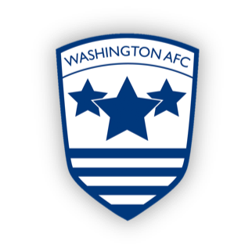

**WASHINGTON AFC**

**Emergency Action Plan**

In the event of a serious injury to any player/spectator/official the following plan will be put in to action.

Key roles:

* Emergency Aid Gary Sykes or Lee Holmes or any Coach on site
* Emergency Co-ordinator Gary Sykes or Lee Holmes

**Emergency Co-ordinator Responsibilities:**

* Call emergency services on 112/999 stating nature of injury as relayed by first aiders and address of venue:

The Northern Area/Northumbria Centre Playing Fields

Stephenson Industrial Estate

Washington

NE37 3HR

* Arrange for someone to meet the paramedic/ambulance in the parking area and direct to the casualty.
* To ensure the remaining players are moved away from the casualty and the surrounding area is kept clear for emergency access.

**Parents/carers Responsibilities:**

* To read and be familiar with the EAP.
* Serious injuries witnessed by young people can have emotional and physical effects on them including upset and shock. It is your responsibility on an occasion such as this to comfort and monitor their reactions. Shock can have a delayed effect.
* If it is your child that is injured please allow the trained emergency aiders to tend to their injuries.
* If a player does not have parents/carers present then we would ask someone else to take responsibility for their care while emergency aid is being administered to the injured person.
* If the Emergency Co-ordinator as named above is not present then a volunteer/nominated person will be required to carry out the role.
* If either Emergency Aider is not present then a volunteer/nominated person may be required to assist. Please make it known to the coach if you have a valid First/Emergency Aid Certificate.

Non-emergency Treatment:

* The nearest medical treatment centre is:

Queen Elizabeth Hospital

Sheriff Hill

Gateshead

NE9 6SX

A&E – 0191 482 0000